NAME – JAY KALYANBHAI SAVANI  
CWID - 20009207

**THREAT ASSESSMENT MATRIX  
FOR STUDY PLACE**

**INTRODUCTION**

Study Place is a fictitious company, where students enroll in the program, learn new courses according to their requirements and develop their skills depending on the courses they enroll in. Teaching faculty are registered in the Study Place platform where they teach various courses. It is a platform that allows instructors to build online courses on their preferred topics.

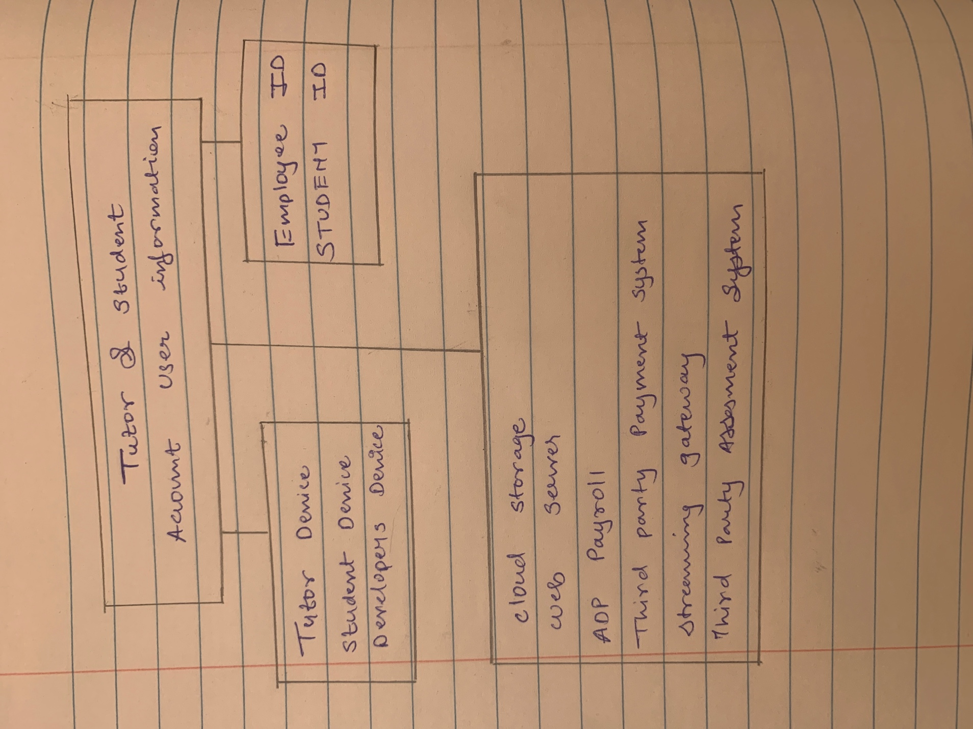

|  |  |  |  |  |  |
| --- | --- | --- | --- | --- | --- |
| Assets | Integrity | Availability | Theft | Confidentiality | Total |
| Employee Id | R=4 P=1 C=4 | R=3 P=1 C=3 | R=2 P=2 C=1 | R=6 P=3 C=2 | 15 |
| Student Id | R=6 P=3 C=2 | R=3 P=1 C=3 | R=2 P=2 C=1 | R=5 P=5 C=1 | 17 |
| Tutor device | R= 3 P=3 C=1 | R= 2 P=2 C=1 | R=4 P=2 C=2 | R= 2 P=1 C=2 | 11 |
| Student Device | R=6 P=3 C=2 | R=4 P=2 C=2 | R=6 P=2 C=3 | R=3 P=1 C=3 | 19 |
| Developer device | R=4 P=2 C=2 | R=2 P=1 C=2 | R=3 P=3 C=1 | R= 4 P=2 C=2 | 13 |
| Cloud Storage | R=3 P=1 C=3 | R=6 P=3 C=2 | R=3 P=3 C=1 | R=3 P=1 C=3 | 12 |
| Web Server | R=6 P=2 C=3 | R=4 P=4 C=4 | R=4 P=2 C=2 | R=4 P=2 C=2 | 18 |
| ADP Payroll | R=6 P=2 C=3 | R=4 P=2 C=2 | R=2 P=2 C=1 | R=4 P=2 C=2 | 16 |
| Third Party Payment | R= 3 P=3 C=1 | R=4 P=1 C=4 | R=1 P=1 C=1 | R=3 P=1 C=3 | 11 |
| Streaming Gateway | R=4 P=2 C=2 | R=6 P=2 C=3 | R=3 P=3 C=1 | R=1 P=1 C=1 | 14 |
| Third Party Assessment | R=2 P=2 C=1 | R=3 P=1 C=3 | R=4 P=2 C=2 | R=4 P=4 C=1 | 13 |

P – Probability  
C – Consequences  
R : Risks = P * C

Assessment in DESCENDING order

|  |  |
| --- | --- |
| ASSESSTMENT | TOTAL |
| Employee Id |  |
| Student Id |  |
| Tutor device |  |
| Student Device |  |
| Developer device |  |
| Cloud Storage |  |
| Web Server |  |
| ADP Payroll |  |
| Third Party Payment |  |
| Streaming Gateway |  |
| Third Party Assessment |  |